**Electricity Production by Source**

Are you aware that excessive reliance on non-renewable energy sources in the next century will result in severe consequences? These repercussions encompass a significant rise in greenhouse gasses, leading to amplified climate change and detrimental effects on the environment. Moreover, ecosystems will be devastated, accessing resources will become challenging, and societies may face potential collapse. Conflict between nations may arise as a result of these circumstances. This detrimental trajectory threatens the existence of our planet, ultimately eradicating all life on Earth and inflicting widespread suffering and anguish. Unless immediate action is taken to adopt renewable and sustainable energy sources, the future appears bleak.

**Contents**

**Project Overview**

**Problem Statement**

**KPI and Data Dictionary**

**Executive Summary and the problems that occurred during the project.**

**Key Insights**

**Recommendations**

**Deployment**

**Project Overview**

Are you aware that excessive reliance on non-renewable energy sources in the next century will result in dire consequences? These repercussions encompass a substantial increase in greenhouse gasses, leading to significant climate change and adverse impacts on the natural world. Ecosystems will be decimated, resource scarcity will intensify, and societal disintegration may occur. The potential for conflicts between nations due to these circumstances is high. This destructive path brings humanity perilously close to extinction, leaving no life on Earth and causing immense suffering. Unless immediate action is taken to adopt renewable and environmentally friendly energy sources, the future appears bleak.

**Problem Statement**

The global community recognizes the crucial need to transition from non-renewable energy sources to renewable alternatives in order to address the challenges posed by climate change and reduce greenhouse gas emissions. However, this transition presents various obstacles. One of the key challenges is the significant upfront costs associated with adopting renewable technologies. Additionally, intermittent energy generation from renewable sources requires reliable energy storage solutions to ensure a consistent and dependable electricity supply.

In 2019, the production of renewable energy sources worldwide saw a remarkable increase of 141% compared to the levels recorded in 2000. On the other hand, non-renewable energy sources experienced a 33% increase during the same period. China emerged as the leading producer of renewable energy, accounting for 32% of the global total in 2019. The United States followed as the second-largest producer, contributing 12% to the world's overall renewable energy production. Brazil held the third position with 7.4%, and India ranked fourth with 4.3%.

Regarding non-renewable energy production in 2019, China was the largest contributor, accounting for 34% of the global total. The United States held the second position with a 20% share, followed by India with 7% and Russia with 5%.



**KPIs**

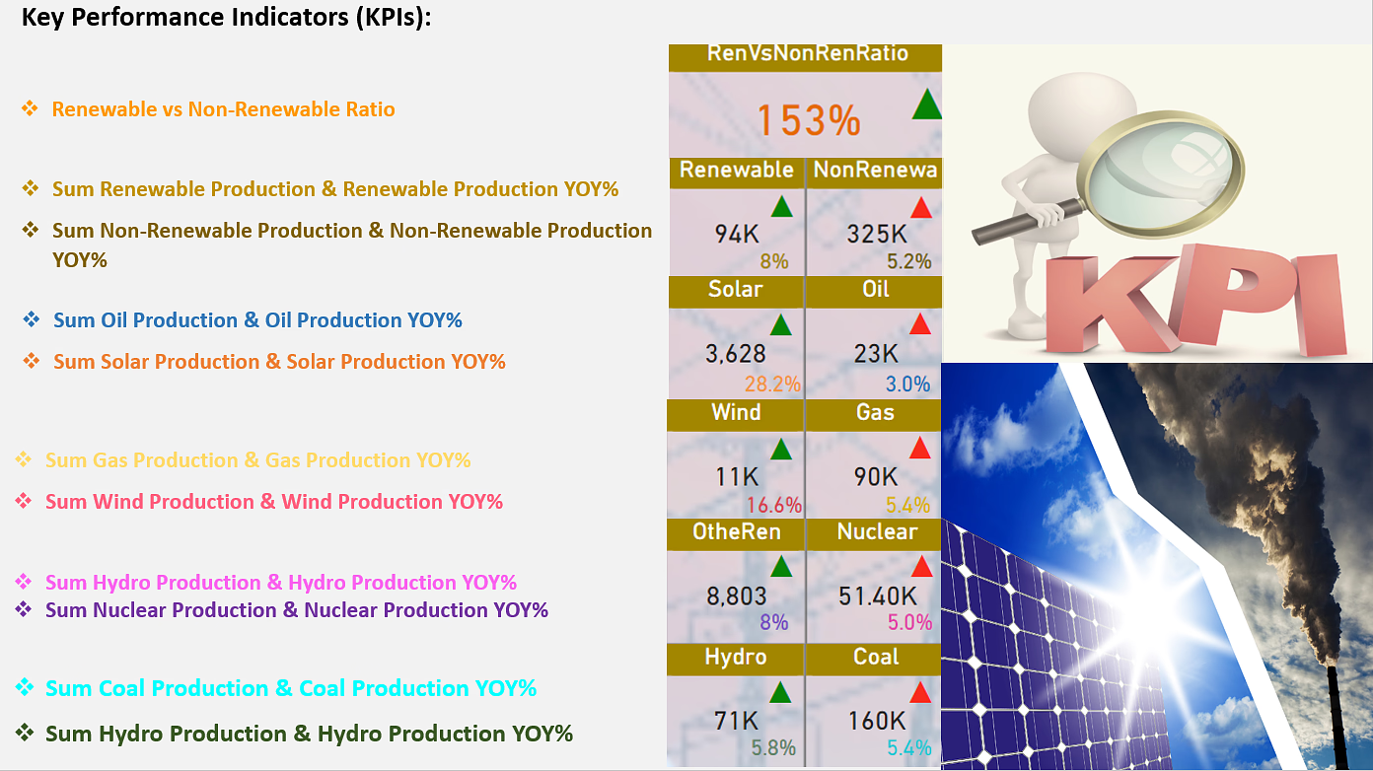

| **Coal YoY = DIVIDE([Total Coal Production]-[Total Coal LY],[Total Coal LY],0)** |
| --- |
| **Gas YoY = DIVIDE([Total Gas Production]-[Total Gas LY],[Total Gas LY],0)** |
| **Hydro YoY = DIVIDE([Total Hydro Production]-[Total Hydro LY],[Total Hydro LY],0)** |
| **Non Renewable YoY = DIVIDE([Total Non Renewables]-[Total Non Renewables LY],[Total Non Renewables LY],0)** |
| **Nuclear YoY = DIVIDE([Total Nuclear Production]-[Total Nuclear LY],[Total Nuclear LY],0)** |
| **Oil YoY = DIVIDE([Total Oil Production]-[Total Oil LY],[Total Oil LY],0)** |
| **Other Renewable YoY = DIVIDE([Total Other Renewable Production]-[Total Other Renewable LY],[Total Other Renewable LY],0)**  **Renewable YoY = DIVIDE([Total Renewable]-[Total Renewables LY],[Total Renewables LY],0)** |
| **Renewables Non Renewables Ratio = DIVIDE([Total Renewable],[Total Non Renewables])** |
| **Solar YoY = DIVIDE([Total Solar Production] -[Total Solar LY],[Total Solar LY],0)** |
| **Total Coal LY = CALCULATE([Total Coal Production],DATEADD(Calender[Start Of Year],-1,YEAR))** |
| **Total Coal Production = SUM('Electricity Production'[Electricity from coal (TWh)])** |
| **Total Gas LY = CALCULATE([Total Gas Production],DATEADD(Calender[Start Of Year],-1,YEAR))** |
| **Total Gas Production = SUM('Electricity Production'[Electricity from gas (TWh)])** |
| **Total Hydro LY = CALCULATE([Total Hydro Production],DATEADD(Calender[Start Of Year],-1,YEAR))** |
| **Total Hydro Production = SUM('Electricity Production'[Electricity from hydro (TWh)])** |
| **Total Non Renewables = SUM('Electricity Production'[Non Renewables])** |
| **Total Non Renewables LY = CALCULATE([Total Non Renewables],DATEADD(Calender[Start Of Year],-1,YEAR))** |
| **Total Nuclear LY = CALCULATE([Total Nuclear Production],DATEADD(Calender[Start Of Year],-1,YEAR))** |
| **Total Nuclear Production = SUM('Electricity Production'[Electricity from nuclear (TWh)])** |
| **Total Oil LY = CALCULATE([Total Oil Production],DATEADD(Calender[Start Of Year],-1,YEAR))** |
| **Total Oil Production = SUM('Electricity Production'[Electricity from oil (TWh)])** |
| **Total Other Renewable LY = CALCULATE([Total Other Renewable Production],DATEADD(Calender[Start Of Year],-1,YEAR))** |
| **Total Other Renewable Production = SUM('Electricity Production'[Electricity from other renewables (TWh)])** |
| **Total Renewables LY = CALCULATE([Total Renewable],DATEADD(Calender[Start Of Year],-1,YEAR))** |
| **Total Solar LY = CALCULATE([Total Solar Production],DATEADD(Calender[Start Of Year],-1,YEAR))** |
| **Total Solar Production = SUM('Electricity Production'[Electricity from solar (TWh)])** |
| **Total Wind LY = CALCULATE([Total Wind Production],DATEADD(Calender[Start Of Year],-1,YEAR))** |
| **Total Wind Production = SUM('Electricity Production'[Electricity from wind (TWh)])** |
| **Wind YoY = DIVIDE([Total Wind Production]-[Total Wind LY],[Total Wind LY],0)** |

**Data Dictionary**

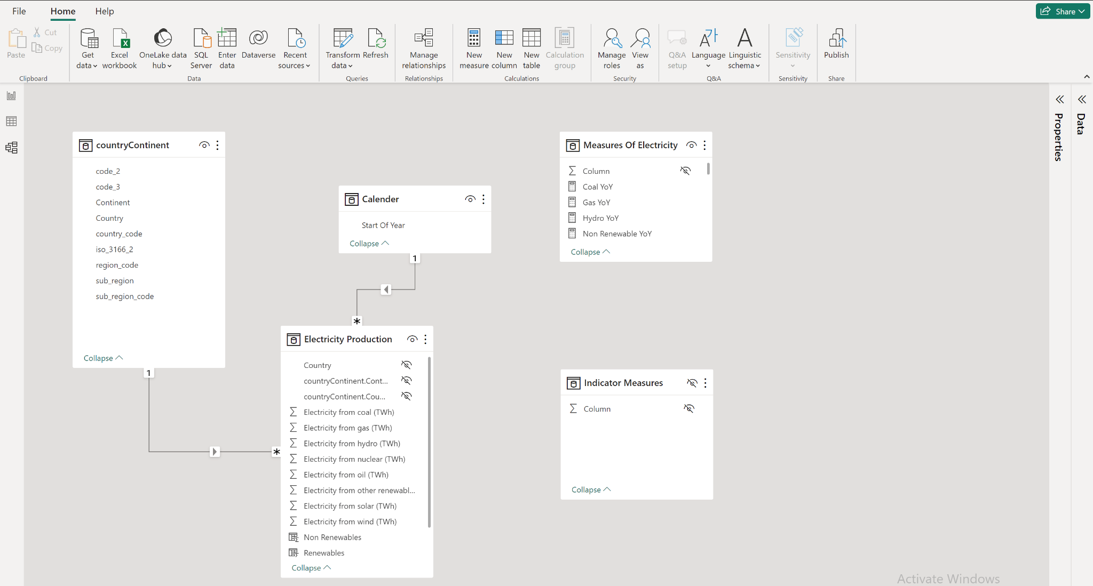

**Executive Summary**

**Challenges faced:**

1. The most daunting obstacle was locating a suitable dataset for the project.

2. Handling a single-to-many data modeling relationship proved to be difficult. Additionally, when attempting to convert the Country-Continent data into CSV files, it did not yield the expected results. As a workaround, I opted for using multiple CSV and Excel files to accommodate the many-to-many relationship.

3. Generating step-by-step gifs that met the size restriction of less than 5MB proved to be both challenging and time-consuming. To minimize the reliance on gifs, I had to commit the steps to memory, enabling me to swiftly transition from one step to the next.

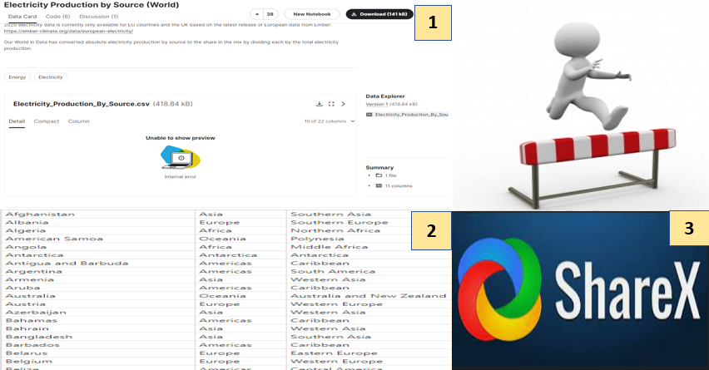

**Key Insights & Takeaways**

# **Key Positive Insights in Power BI:**

# 

1. The world's non-renewable energy production experienced a significant decrease of 12.9% in 2019 compared to the previous year, 201.

2. Nuclear production in Asia witnessed a decline of 23.8% in 2011 when compared to the preceding year, 2010.

3. The continent of Oceania does not possess any nuclear power plants and has a longstanding policy against pursuing nuclear power for electricity generation.

4. In Oceania, there was a reduction of 4.5% in oil production, 7.6% in gas production, and 4.8% in coal production in 2019 as compared to 2018.

# 

# **Key Negative Insight in Power BI:**

# 

1. Nuclear production in Asia recorded a growth of 7.0% in 2009, whereas there was a decrease of 5.8% in the previous year, 2008.

2. Gas production in Europe saw an increase of 7.4% in 2010, contrasting with a decline of 6.9% in the preceding year, 2009.

3. Oil production in Africa rose by 11.3% in 2012, while there was a decrease of 5.0% in the production level during 2011.

# 

# **Suggestions for Producing Renewable Energy and Reducing Non-Renewable Energy:**

# 

1. Country-wise analysis: As of 2019, China, the United States, and India were the top producers of non-renewable energy. China relied heavily on coal for 57% of its energy, while the United States relied on a combination of coal, gas, and nuclear energy. To reduce dependence on non-renewable sources, these countries should focus on transitioning to renewable energy.

2. Increase in non-renewable energy production: The data shows an increase in global non-renewable energy production from 2009 to 2010. Oil, gas, coal, and nuclear energy all experienced varying levels of growth during this period. To combat this trend, a shift towards renewable energy is necessary.

3. Fluctuations in oil electricity production: There was a decrease in non-renewable oil electricity production in 2017, followed by a subsequent increase in 2018. This highlights the need for stability and consistent efforts to transition away from non-renewable sources.

4. Europe's gas production: Europe experienced a significant increase of 7.4% in gas production in 2010 compared to the previous year, which saw a decrease of 6.9%. While gas is considered a cleaner fossil fuel, the focus should still be on renewable energy alternatives.

# **Suggestions for Producing Renewable Energy:**

# 

1. Install solar panels: Utilize solar panels to harness the power of sunlight and convert it into electricity for homes or businesses. This renewable energy source reduces reliance on non-renewable energy.

2. Invest in wind turbines: In areas with strong winds, investing in wind turbines is a viable option to generate clean and renewable energy.

3. Use hydropower: For locations near rivers or bodies of water, harnessing hydropower can generate electricity by utilizing the energy of moving water to turn turbines.

4. Consider geothermal energy: Explore the use of geothermal energy, which taps into the Earth's heat to generate electricity, making it an eco-friendly and renewable alternative.

# 

# **Suggestions for Reducing Non-Renewable Energy Production:**

# 

1. Invest in energy-efficient appliances: Opt for energy-efficient appliances that consume less energy, leading to reduced dependence on non-renewable sources and cost savings.

2. Use public transportation: Minimize reliance on non-renewable energy by utilizing public transportation or adopting alternative modes of transportation such as biking, walking, or carpooling.

3. Support renewable energy policies: Advocate for policies that promote renewable energy, such as tax credits for renewable investments, incentives for energy-efficient buildings, and mandates for increased renewable energy usage by utilities.

4. Reduce energy waste: Implement energy-saving practices like turning off lights when not in use, utilizing programmable thermostats, and maximizing natural light to minimize energy waste and reliance on non-renewable sources.

# 

# 

# 

# 

# **Deployment**

